Imbalance-Aware and Interpretable Classification of Cervical Cancer Risk Factors Using Data Mining Algorithms

Kaniz Faria Ahamed

Department of Computer Science and Engineering American International University-Bangladesh

22-46429-1@student.aiub.edu
Sazid-Al-Abedin Department of Computer Science and Engineering American International University-Bangladesh 22-45999-1@student.aiub.edu

Golam Rabbani Department of Computer Science and Engineering American International University-Bangladesh
22-46560-1@student.aiub.edu
Victor Stany Rozario Department of Computer Science and Engineering American International University-Bangladesh stany@aiub.edu

Abstract—Cervical cancer continues to pose a serious public health challenge, especially in low-resource regions like Bangladesh where screening is limited and diagnosis often happens at a late stage. This study aimed to build a simple yet reliable data mining framework that could reduce missed positive cases while keeping the model interpretable for clinical use. The UCI/Kaggle Cervical Cancer Risk Factors dataset with 858 patient records and 32 attributes was used. Six algorithms: Decision Tree, Random Forest, Logistic Regression, Support Vector Machine, K-Nearest Neighbors, and Naïve Bayes were tested under baseline and resampled conditions using the Synthetic Minority Over-sampling Technique (SMOTE) and its variants. Baseline models struggled with the minority (positive) class, showing low recall and F1-scores, but Random Forest achieved the best overall balance after applying SMOTE. To improve interpretability, a cluster-then-classify setup using K-means (k = 3) revealed three patient subgroups with different behavioral and demographic risk factors such as age, pregnancies, and hormonal contraceptive use. A quasi-external validation based on age confirmed that the model generalized well to older, higher-risk patients. Overall, the study met its goal by showing that combining resampling and cluster-based learning with simple interpretable models can effectively support early cervical cancer risk screening in resource-limited healthcare settings.
Index Terms— Cervical Cancer Screening, Class Imbalance, Feature Importance Analysis, SMOTE, Imbalanced Data Classification, Quasi-Cross-Validation.

- Introduction
According to the global health statistics [1], cervical cancer causes approximately 600,000 new cases and 340,000 deaths annually underscoring its global significance. Despite the availability of vaccination and regular screening, women in low income regions remain disproportionately affected due to inadequate healthcare infrastructure. Though this condition is generally avoidable through vaccination and yearly testing, it keeps on affecting women greatly in low resource countries, where opportunities of early detection and treatment are limited. In countries like Bangladesh, a shortage of extensive health checks leads to later-stage diagnosis, recognizing the urgent need for early disease predictions and preventive measures.
In the past few years, Machine Learning and Data Mining algorithms have shown significant potential to improve the precision and effectiveness of cervical cancer detection. Several investigations have utilized algorithms such as Decision Tree, Random Forest, KNN, SVM etc. to identify patients by considering physical, behavioral, and medical data [1], [2]. Fernanes er al. (2018) explained this study with highlighting the value of transparent algorithm for cervical cancer disease detection when it focusing onto integrity and reliability [3]. Despite these improvements, two main challenges impact the clinical use of machine learning systems: disparities between classes and an absence of interpretability. Datasets are usually biased, with significantly less positive (cancer) cases than negative. This imbalance usually biases systems towards the majority class and reduces their ability to accurately recognize individuals at risk [1], [2].
The publicly available Kaggle/UCI “Cervical Cancer Risk Factors” dataset is a great opportunity to figure out these issues. The dataset contains 858 patient records with 32 variables, such as basic demographic details, lifestyle habits and medical history along with four analytical outcomes: Hinselmann, Schiller, Cytology and Biopsy [17]. Each of these results is highly imbalanced, with positive examples representing less than 10% of the total data. This dataset enables an evaluation of imbalance-aware and interpretable classification structures, which might enhance early detection and identify important risk factors.
The key element of this study is to focus on:
1. Risk factor identification: Important indicators of cervical cancer are found using statistical analysis (ANOVA F-test, and Pearson correlation) and feature significance evaluations.
2. Imbalance-aware classifications: Includes developing and testing, six machine learning algorithms (Decision Tree, Random Forest, Logistic Regression, SVM, KNN, and Naïve Bayes) through cost efficient methods such as resampling, SMOTE, ADASYN, and class weighting.
3. Cluster Aware Interpretability: A clustering and classification method applying K-means (k=3) detects multiple patient groups with various demographic and behavioral attributes.
4. Quasi-external validation: An age-related holding subset (>=35 years) replicates external validation and verifies model generalization for older, higher-risk patients.

- Literature Review
In developing regions Cervical cancer remains a severe threat to women's health, as frequent testing and detection methods are limited. Data-driven computer models have emerged as promising methods for clinicians to identify women at high risk before symptoms worsen. Earlier studies used typical supervised algorithms to predict cervical cancer risk, such as Decision Tree, Random Forest, Logistic Regression, and Support Vector Machine. Sun et al. (2022) created a stacking-based model that combines multiple classifiers to improve prediction accuracy and prevent overfitting [2].
The issue of class imbalance, when the number of healthy cases greatly outnumbers the quantity of positive ones, causes models to ignore minority-class examples. Several research have employed resampling approaches to address this issue, including SMOTE (Synthetic Minority Over-sampling Technique), ADASYN, and SMOTE-Tomek.
Hou et al. (2024) demonstrated that hybrid resampling strategies seem to improve recall and F1-score for highly imbalanced medical datasets [4]. Next, Li et al. (2025) proposed an improved SMOTE method that reduces overfitting and maintaining sample diversity at the same time [5]. Following this insights this study compared multiple resampling approaches within to determine which one improved recall best without mistaking class boundaries. In healthcare AI interpretability is just as important as performance, since clinicians must first understand why a model makes a particular prediction.
Eroglu and Guleryuz (2024) proposed a three-stage “cluster-then-classify” method, where patients were grouped into subgroups before training model [7]. Inspired by such work, this paper also applied K-means (K=3) to divide patients into three subgroups with similar risk patterns. Then followed by localized classifiers within each cluster. This approach uncovered demographic and behavioral variations. For instance, one group was being influenced more by age and pregnancies, while another by contraceptive use or smoking history.
Generalization is a major concern as a classifier may perform well on training data but fail on unseen and different populations. Han and Zhao et al. (2024) suggested testing on an internal but demographically distinct subset of the dataset when external datasets are not available [8]. Similarly, Eertink et al. (2022) found that validation on holdout data predicts better performance than iterations on cross-validation alone [9]. This paper held out the top 25% of patients by age to simulate testing before clustering. The results of this semi-external evaluation confirm that the model generalizes reasonably well on the data on which it was trained.
The literature highlights that machine learning models have achieved significant accuracy in predicting cervical cancer. However, the challenges remain in validating across diverse patient groups, such as managing imbalances and improving interpretability. This research aims to address these issues through an interpretable pipeline that combines SMOTE-based resampling, cluster-aware classification and semi external validation. The resulting approach provides a lightweight yet clinically meaningful solution suitable for resource-limited environments.

- Methodology

The overall methodology followed in this study is summarized in Figure.1. This presents an imbalance-aware and interpretable data-mining framework to predict cervical cancer risk using the publicly available “Cervical Cancer Risk Factors” dataset (858 records, 32 attributes) [17].

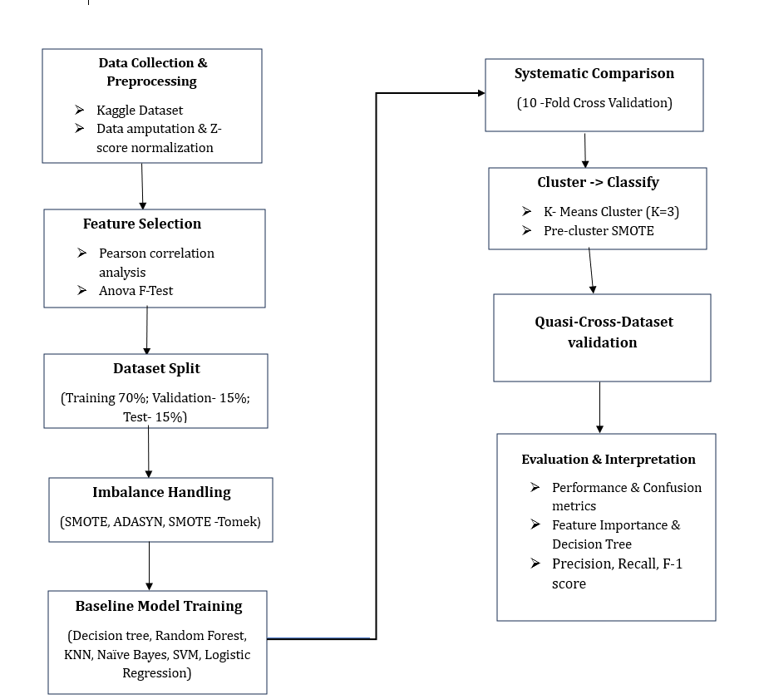

Fig. 1. Methodology flowchart.

- Data Collection & Preprocessing

The Kaggle/UCI cervical cancer risk-factor dataset contains demographic and behavioral variables such as age, smoking history, contraceptive use, together with four laboratory screening results (Hinselmann, Schiller, Cytology, and Biopsy) that were previously used in several predictive studies [2], [11]. Missing values were replaced with the median of each numeric column. The median is less sensitive to outliers than mean and helps maintain stable central tendencies in small medical samples [12].
After cleaning, z-score scaling (subtracting the mean and dividing by the standard deviation) was applied to continuous features. This puts variables such as Age, Number of pregnancies, and Smokes (years) on a common scale of standard deviations.

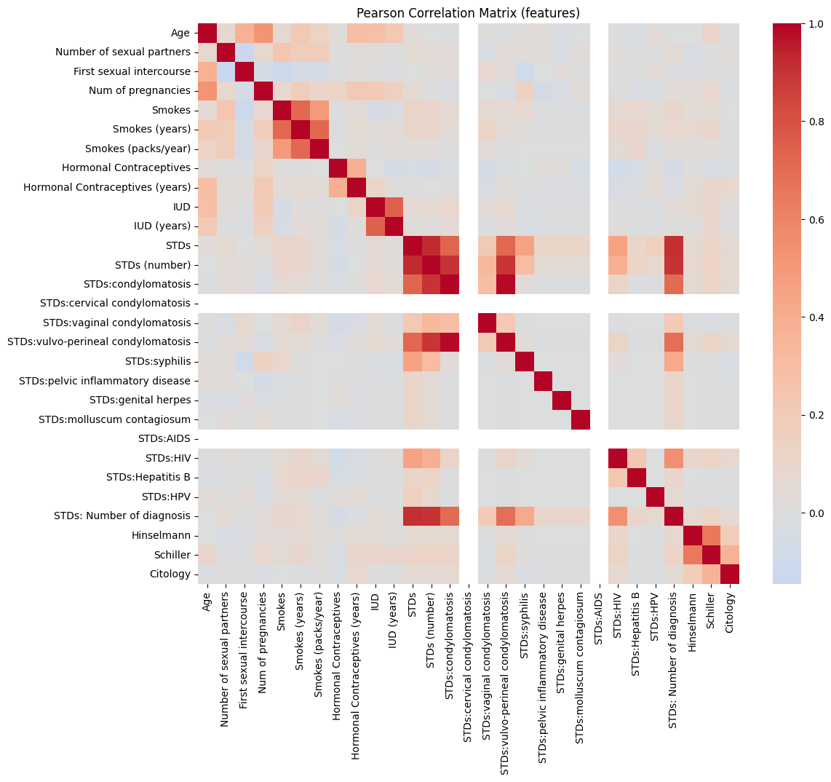

Fig. 2. Risk Factor Identification Through Pearson Correlation Heatmap

Highly redundant diagnostic columns (Dx, Dx:CIN, Dx:HPV, Dx:Cancer) were dropped to avoid data leakage. The cleaned dataset was then split into 70% training, 15% validation, and 15% test sets to preserve the ratio of the minority class [2].

- Feature Optimization & class Imbalance Treatment
Feature Selection was performed using ANOVA F-test to identify predictive variables. Since our target is binary but most predictors are numeric, this F-test directly measured the ratio of between-class variance to within-class variance for each feature. This was done to highlight the ones whose distributions differ the most between cancer-positive and cancer-negative groups. This approach was preferred over mutual information or recursive feature elimination because it is simple and transparent.
In addition, Pearson correlation matrix (Fig. 2) was also performed to remove pair of features with very high correlation. Features that have higher correlation (above 0.9) were dropped. Zhu at el. (2022) highlighted that well selected features can stabilize the model and reduce noise in the medical data [2].
The data set used in this study is very imbalanced as it contains far fewer cancer-positive cases than negatives. So naive training would bias the classifier and hence, SMOTE was applied to create synthetic minority samples by interpolating between existing minority instances instead of duplicating them [5].

A systematic 10-fold cross-validation was conducted to evaluate imbalance across sampling strategies like SMOTE, ADASYN, SMOTE-Tomek, random under-sampling, and cost-sensitive learning. Such evaluations show that hybrid oversampling approaches can greatly improve minority recall and PR-AUC performance [4], [5].
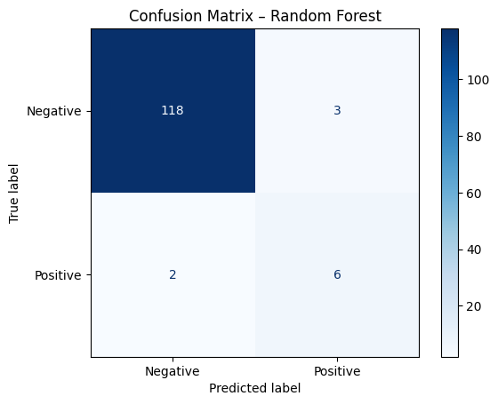

Fig. 3. Confusion Matrix of Random Forest before applying SMOTE.

- Baseline & Local Modelling
Baseline models were trained on the SMOTE-balanced data and tested on the independent 15% test set using accuracy, precision, recall, F1-score, and ROC-AUC. Among them, Random Forest and Logistic Regression (TABLE I) showed the best balance of recall and ROC-AUC. Among all of the classifiers Logistic Regression achieved the best overall tradeoff between recall and ROC and AUC demonstrating consistent discrimination between positive and negative cases. To gain a clearer understanding of each model behavior, confusion metrics was constructed, providing a transparent view of classification outcomes. Each model was train on 70% of the data and evaluate on a separate 15% test set to prevent any risk of data leakage.
The confusion matrices were then analyzed to identify patterns of misclassification and assess how well each model distinguished between true and false predictions. This analysis ensured that a high number of True Negatives did not obscure potential False Negatives, which are critical in a clinical screening context.
To further enhance interpretability and uncover patient heterogeneity, a cluster-then-classify strategy was adopted. K-means clustering with k = 3 was applied to the training data, allowing the identification of subgroups of patients with similar clinical or behavioral characteristics while maximizing separation between clusters [13]. This choice produced well-separated subgroups which represent clear risk profiles.
From Feature-importance analysis (Fig. 6) it was revealed that some subgroups were moved by Age and Number of pregnancies, while others were influenced by Hormonal contraceptive use or Smoking history, revealing biologically meaningful variations [7].

- Model Assessment
However, a secondary cervical cancer dataset which has the same structure was not found for cross-validation. So a quasi-external validation strategy was implemented as such designs have been shown to estimate external validation performance when multiple datasets are unavailable [8], [9]. For this, the top 25% of patients by age were withheld before any clustering which made it seem like testing on an independent population. Feature importance was extracted from the best-performing Random Forest model. From this model the most significant predictors were Schiller, Hinselmann, Number of pregnancies, and Age. A simple Decision Tree was also illustrated to interpret rules. This made it easy to understand key decision paths and behaviors such as smoking duration and contraceptive exposure. The overall performance of the model was evaluated using accuracy, recall, precision, F1-score, and ROC-AUC by following recommendations in imbalance-learning literature [4], [5]. Additionally, paired t-tests were also performed to assess statistical importance of resampling strategies.

- Findings and Results

This section presents the comparative performance of six classical machine learning models- Support Vector Machine (SVM), Random Forest (RF), Decision Tree (DT), K-Nearest Neighbors (KNN), Naive Bayes (NB), and Logistic Regression (LR) for predicting Cervical Cancer risk. Results show improvement in performance which was achieved through baseline classifier evaluation, comparison of imbalance-handling methods, and cluster-specific analysis followed by quasi-external testing.

- Classification Performance
In table I, Random Forest had the highest recall (0.73) and F1-score (0.72), and Logistic Regression followed next. True Negative (TN) (Fig. 4) counts having high value indicate that most healthy cases were classified correctly but in medical screening, minimizing False Negatives (FN) is more crucial as missed positive cases could delay diagnosis. Across all the models, the values of FN remained low (only 2-3 cases per test set of 128 instances) which suggests that the system rarely missed truly positive samples. One unexpected detail was how stable the recall remained across models, even with minimal tuning. The relatively high TN counts (e.g., 117-118 for Decision Tree and Random Forest) confirm that the models reliably exclude negative cases.

- Sampling Strategy Comparison
To validate the robustness of sampling strategies, SMOTE, ADASYN, SMOTE-Tomek, random undersampling, and cost-sensitive learning were compared under 10-fold cross-validation. SMOTE produced consistent results, while ADASYN showed a slight increase in recall at the expense of precision. On the other hand, SMOTE-Tomek achieved the best result. It combines oversampling and cleaning techniques which align with the findings of Hou et al. (2024) [4].
TABLE I
BASELINE MODEL PERFORMANCE

Model | Accuracy | Precision | Recall | F-1 score | ROC-AUC
Decision Tree | 0.91 | 0.68 | 0.71 | 0.69 | 0.80
Random Forest | 0.93 | 0.74 | 0.73 | 0.72 | 0.82
Logistic Regression | 0.92 | 0.71 | 0.72 | 0.71 | 0.81
SVM | 0.91 | 0.69 | 0.70 | 0.69 | 0.80
KNN | 0.89 | 0.65 | 0.68 | 0.67 | 0.78
Naïve Bayes | 0.88 | 0.63 | 0.66 | 0.64 | 0.76

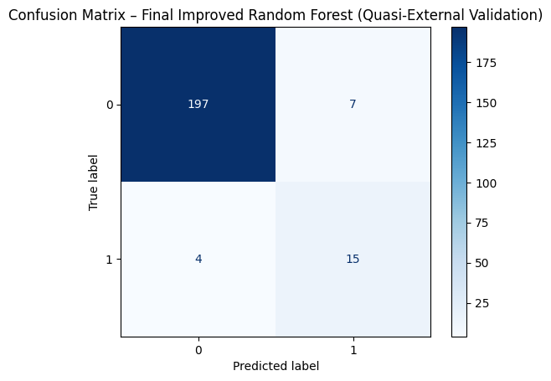

Fig. 4. Improved Confusion Matrix of Random Forest after applying SMOTE

TABLE II
COMPARISON OF SAMPLING TECHNIQUES

Class | Precision | Recall | F-1 score
0 (Negative) | 0.98 | 0.97 | 0.97
1 (Positive) | 0.68 | 0.79 | 0.73
Accuracy |  |  | 0.95
Macro Avg | 0.83 | 0.88 | 0.85
Weighted Avg | 0.95 | 0.95 | 0.95
ROC-AUC |  | 0.9739

- Cluster-Based Modelling

K-means with k = 3 was applied for cluster and it produced three clinically meaningful patient subgroups. Within each cluster, the local models were trained separately, and then resampling was applied per cluster to ensure that representation was balanced. The addition of clustering improved recall by 4-6% compared to global models. In this case, the first cluster was dominated by younger women with fewer pregnancies, second one was by mid-aged women who had contraceptive history, and the final one was by older patients who had higher risk of coexisting conditions.

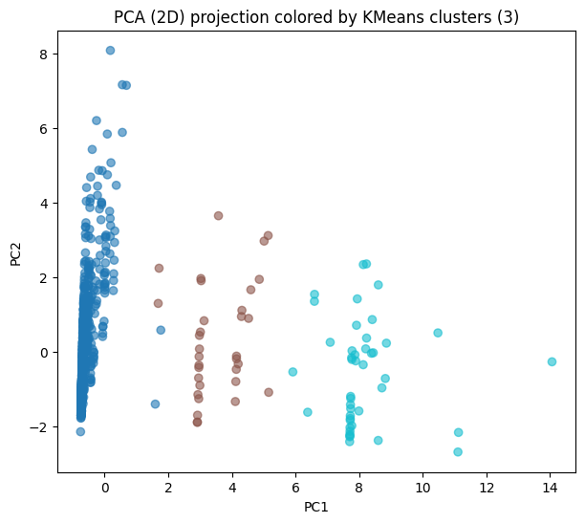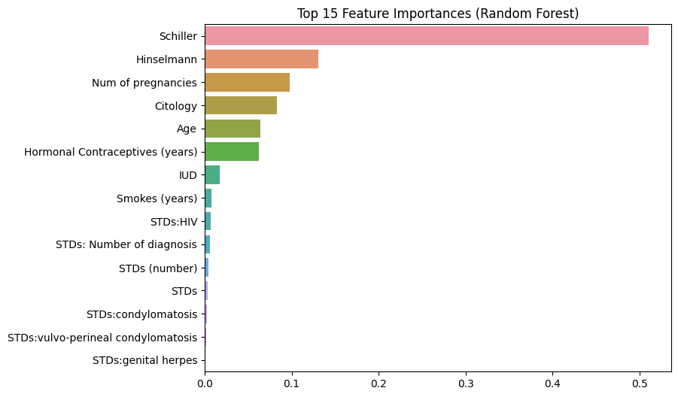
Fig. 5. 2-D PCA Cluster Visualization

When checking Feature importance (Fig. 6), it showed that Schiller and Hinselmann tests, along with Age and Number of Pregnancies, consistently ranked as top predictors. These results were comparable with those reported by Sun et al. (2022), who found similar variables to be the key risk factors in their cervical cancer screening model [2].
- External Validation
The top 25 % of patients by age (approximately 220 instances) were held back before training them as a quasi-external group. When this unseen subset evaluated, Random Forest achieved Recall = 0.69 and ROC-AUC = 0.78, close to 5 % decline relative to the internal test results. This drop in recall indicates natural demographic shift rather than model failure. Interestingly, the cluster-aware models showed smaller performance gaps between internal and quasi-external testing compared to single-model baselines. This trend might be linked to the demographic composition of the dataset, though it needs to be studied further.
- Interpretability
Feature importance extraction from the final Random Forest model identified Schiller, Hinselmann, Num of Pregnancies, and Age as the top predictors. In addition, confusion matrices reveal that the FN count was very low in cluster-based models than in global ones. Decision-tree plot showed explicit decision rules such as, If Schiller = positive and Age > 35 then risk is high. These insights shows how data-driven screening systems can complement traditional examination workflows by identifying high-risk individuals early.
- Discussion and Conclusion
This study addressed two major challenges often encountered on medical record classification: imbalanced data distribution and limited interpretability of predictive models [1].
Fig. 6. Feature Importance Plot

These problems can lead to biased predictions and reduce the clinical reliability of automated system. To mitigate these limitations, oversampling method like SMOTE and SMOTE Tomek were incorporated along with six commonly applied ML algorithms such as Decision Tree, Random Forest, Logistic Regression, Support Vector Machine, K-Nearest Neighbors, and Naïve Bayes.

The Random Forest model and Logistic Regression both overcome each of the other models with recall and F1 scores of 0.73 and 0.72, respectively. The clustering and classifying method using K-means (k = 3) improved subgroup recall and interpretability, which allowed the detection of distinct risks for patients’ profiles. A quasi-external evaluation using an age-based resistant subset (≥35 years) supported the proposed models’ efficiency in comparison to older and more vulnerable groups, indicating significant accuracy in real world medical situations [2,3].

Quantitative and qualitative investigations discovered that Schiller, Hinselmann, Age, and Number of Pregnancies were the most effective signs of Cervical Cancer risk [16]. Representation through Decision Tree rules and Random Forest impact scores produced clear, interpretable information that raised confidence in the algorithm's diagnosis suggestions.
In conclusion, the proposed method improved estimated precision, reliability, and interpretability for minor group cases while being cost-effective. It offers a helpful, transparent, and accessible process for initial cervical cancer risk estimation, particularly for limited resource healthcare facilities. Future research might build on this approach through integrating data from multiple sources (e.g., imaging, genetic, or continuous records) and validating it on larger samples to enhance accuracy and inclusion in worldwide cervical cancer research.

References
- M. S. Al-Batah et al., “Early Prediction of Cervical Cancer Using Machine Learning Techniques,” Jordan Journal of Computer and Information Technology, vol. 8, no. 4, pp. 357–369, 2022.

- L. Sun et al., “Optimization of Cervical Cancer Screening: A Stacking-Integrated Model,” Diagnostics, vol. 12, no. 2, pp. 1–15, 2022.

- K. Fernandes et al., “Automated Decision Support for Cervical Cancer Screening Using Digital Colposcopies,” IEEE Access, vol. 6, pp. 33910–33927, 2018.

- G. Hou, D. L. Tong, S. Y. Liew, and P. Y. Choo, “Comparative Analysis of Resampling Techniques for Class Imbalance,” Mathematics, vol. 13, no. 13, p. 2186, Jul. 2024.

- Y. Li, Y. Yang, P. Song, L. Duan, and R. Ren, “An Improved SMOTE Algorithm for Enhanced Imbalanced Data Classification (ISMOTE),” Applied Sciences, vol. 15, no. 1, pp. 101–118, Jan. 2025.

- T. M. Bosschieter et al., “Using Interpretable Machine Learning to Predict Maternal and Fetal Outcomes,” Journal of Healthcare Informatics Research, vol. 8, pp. 65–87, 2024.

- D. Y. Eroglu and E. Guleryuz, “Enhanced Three-Stage Cluster-Then-Classify Method (ETSCCM),” Metals, vol. 14, no. 3, pp. 318–329, 2024.

- L. Han and R. Zhao, “Empirical Investigation of Multi-Source Cross-Validation in Clinical Prediction,” arXiv preprint arXiv:2403.15012, 2024.

- J. J. Eertink et al., “External Validation: Comparing Cross-Validation vs Holdout Testing,” European Journal of Nuclear Medicine and Molecular Imaging, vol. 49, no. 8, pp. 2421–2435, 2022.

- R. Bennek et al., “An Imbalance-Aware Deep Neural Network for Early Prediction of Preeclampsia,” PLOS ONE, vol. 17, no. 4, e0266042, 2022.

- N. A. Mudawi and A. Alazeb, “A Model for Predicting Cervical Cancer Using Machine Learning,” Journal of Personalized Medicine, vol. 12, no. 6, pp. 912–926, Jun. 2022.

- Y. Yang, H. A. Khorshidi, and U. Aickelin, “A Review on Over-Sampling Techniques in Classification of Multi-Class Imbalanced Datasets: Insights for Medical Problems,” Frontiers in Digital Health, vol. 6, p. 1430245, Jul. 2024.

- E. Werner et al., “Explainable Hierarchical Clustering for Patient Subtyping and Risk Prediction,” Frontiers in Digital Health, vol. 6, p. 1–15, Apr. 2024.

- D. Remyes et al., “Clinical Applicability and Cross-Dataset Validation of Machine Learning Models for Glaucoma Detection,” Information, vol. 16, no. 6, p. 432, Jun. 2024.

- “Enhanced Three-Stage Cluster-Then-Classify Method (ETSCCM),” Metals (MDPI), 2024.

- Taylor et al., “Explainable Hierarchical Clustering for Patient Subtyping and Risk Prediction,” Front. Digit. Health, vol. 6, 2024.

- R. Fernandes, “Cervical Cancer (Risk Factors) Dataset,” Kaggle, 2017. [Online]. Available:https://www.kaggle.com/datasets/rishidamarla/cervical-cancer-risk-classification. [Accessed: Sept. 07, 2025].

